Module 10 – MOLP

Exploratory Data Analysis

*In this section, you should perform some data analysis on the data provided to you. Please format your findings in a visually pleasing way and please be sure to include these cuts:*

Model Formulation

*Write the formulation of the model into here prior to implementing it in your Excel model. Be explicit with the definition of the decision variables, objective function, and constraints. For this problem, I am only asking that you perform the model formulation for the MOLP model.*

Decision Variables:

Xij = # of units being shipped from node i to node j

Objective Function:

W1(17X14+24X15+24X16+10X17+20X23+10X24+19X32+14X34+10X37+24X45+16X51+11X52+10X53+24X54+7X57+15X61+18X62+23X63+24X64+11X65+21X67+8X71+24X72+16X73-221,527/221,527)<=Q

W2(17.87X14+3.23X15+14.62X16+15.36X17+25.48X23+8.87X24+25.48X32+27.91X34+6.06X37+21.10X45+3.23X51+18.53X52+7.01X53+21.10X54+12.14X57+14.62X61+9.21X62+24.53X63+3.59X64+17.83X65+29.97X67+15.36X71+29.74X72+6.06X73-147,229/147,229)<=Q

W3(X14+X15+X16+X17+X23+X24+X32+X37+X51+X52+X53+X54+X57+X61+X62+X63+X64+X67+X71+X72+X73-12,993/12,993)<=Q

W4(X14+X15+X16+X17+X23+X24+X32+X37+X45+X51+X52+X53+X54+X57+X61+X62+X63+X64+X65+X67+X71+X72+X73-12,993/12,993)<=Q

Constraints:

Xij>=0

W1,W2,W3,W4<=Q

Xi Net Flow>=Xi Supply/Demand

Model Optimized for Equally Weighted Objectives

*Implement your formultion into Excel and be sure to make it neat. This section should include:*

* *A screenshot of your optimized final model (formatted nicely, of course)*
* *A text explanation of what your model is recommending*
* *Update your graph from the EDA section to indicate which arcs are used*

*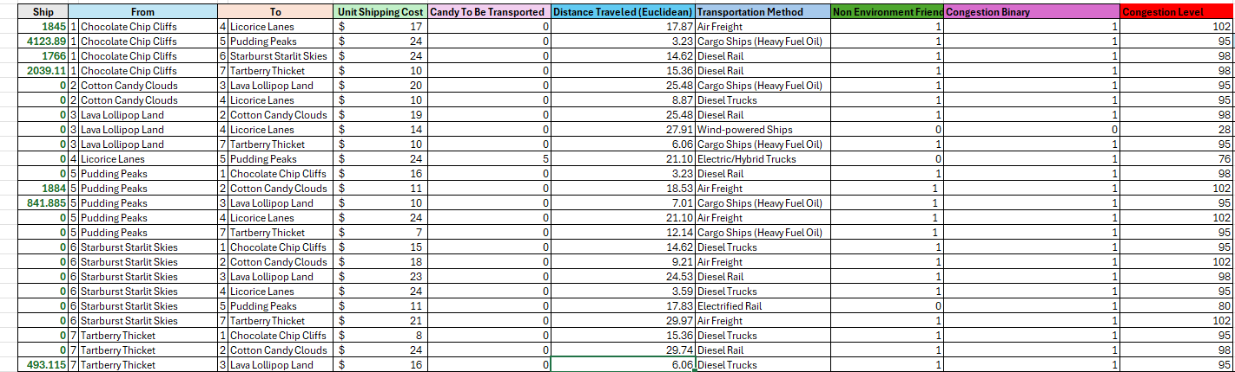*

*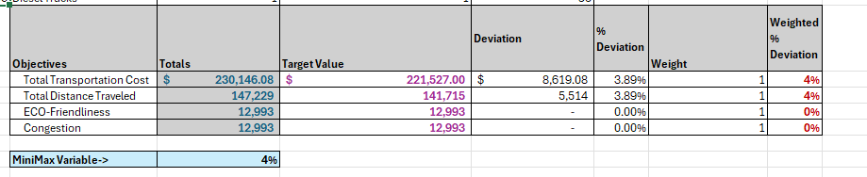*

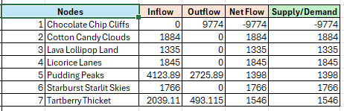

This model is recommending that the Fish and Murr’s Candy Shop should ship 1845 units across route 14, about 4124 units across route 15, 1766 units across route 16, about 2039 units across route 17, 1884 units across route 52, about 842 units across route 53, and about 493 units across route 73.

Model with Stipulation

*Please copy the tab of your original model before continuing with the next part to avoid messing up your original solution.*

*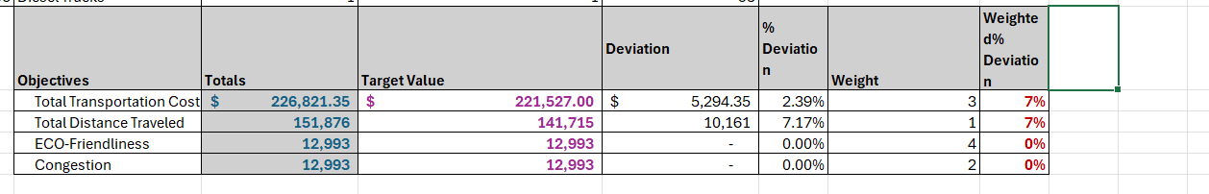*

*Alter the weights of each objective to add weight to match what matters most to you. Perhaps run a few different scenarios to see how the routes change depending on the weights. When you find a weight mix and solution that satisfies you, please write a justification on why you chose the final model/weights and about how a configured model like yours can be used for scenario planning.*

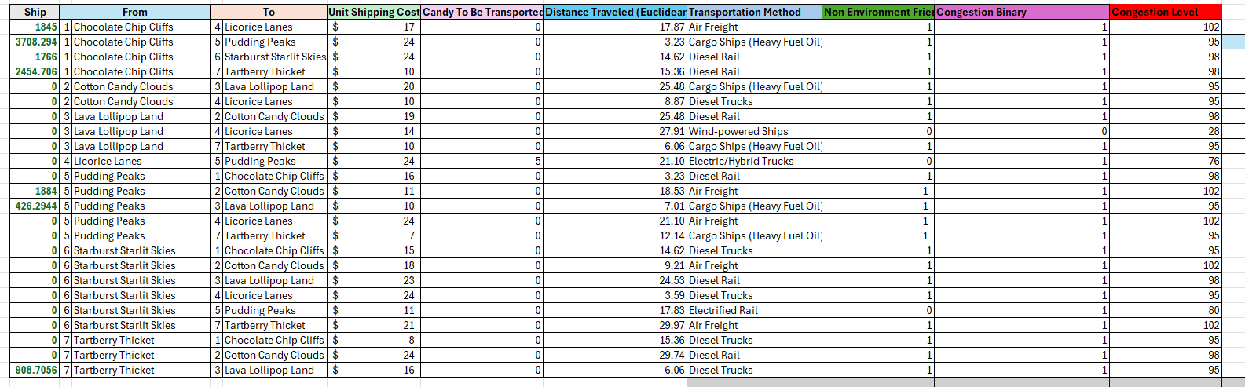

I chose these weights for the final model because I want my candy shop to contribute to the well-being of the planet in every way possible. Due to this being an essential part of our business model, this was our highest priority and therefore had the highest weight. We also want to be efficient with our resources, which is why keeping total transportation costs as low as possible was our second-highest priority. A configured model like this can benefit our business, because if we get into a desperate financial situation where costs have to be minimized to as little as possible, we can boost the weight of the costs and lower our other priorities. Another situation that could arise is if we have a shortage of truck drivers, and we need to lower the number of miles that each driver has to travel in order to avoid them getting over tired and ending up in dangerous situations. The ability to adjust the weights to changing priorities makes a model like this very helpful to our candy business.